Hello everyone!
My name is Kristína and I´m a student of the Faculty of Medicine in Bratislava. I participated in the IFMSA Exchange in Northern Cyprus in July. My first choice was another country but now I´m very happy for my second choice as I had a really good experience there.
To come to the Northern Cyprus was little complicated because you need to cross the border between south and north but it was nothing to worry about. After crossing border my contact person was waiting for me and gave me a drive to dormitories. My accomodation was totaly perfect. Big new appartment for two persons with everything you need. There were 2 AC, big kitchen and bathroom with washing machine. It was located at the campus 15 minutes from the hospital by walk. There was everyting you need as market, gym, swimming pool etc. Public transport was not very frequent because of summer holiday but we usually took a taxi as a group from the city in the evening.
My first impression from intership was great. Near East Universtity hospital there is private, modern property with a lot of professionals. There was located also a cafeteria where we had meals three times per day. I attended department of Peadiatrics with group of 6th year studenty who had summer practice there. I was mainly at Policlinics but I was also able to participate in many surgeries mainly C-sections and newborn care after that. Triples CS and intensive care after impressed me the most.
Northern Cyprus medical students association made as full-featured program for everyday. Sometimes I even made myself a free day and skiped the program because I needed rest. We visited many beaches , historic places and cities. Every weekend we had a trip to another part of the island for camping, diving or party.
I recommend everyone visiting Northern Cyprus.
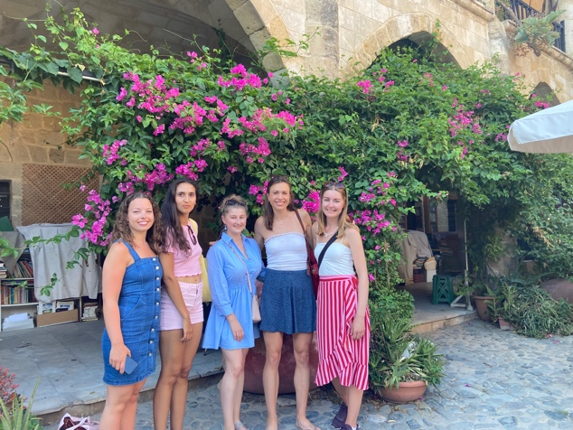
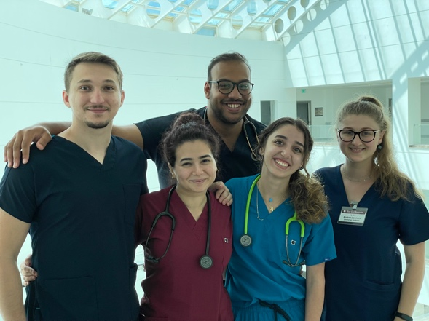
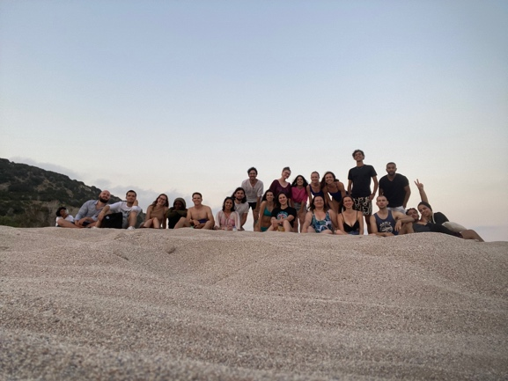
Kristina.

